Science Center Research Park 3711 Market St. Philadelphia, PA
The Pennsylvania State University Department of Architectural Engineering Senior Thesis 2009-2010

Prepared by:
Zachary Yarnall

April 7, 2010

[Final Thesis Report]

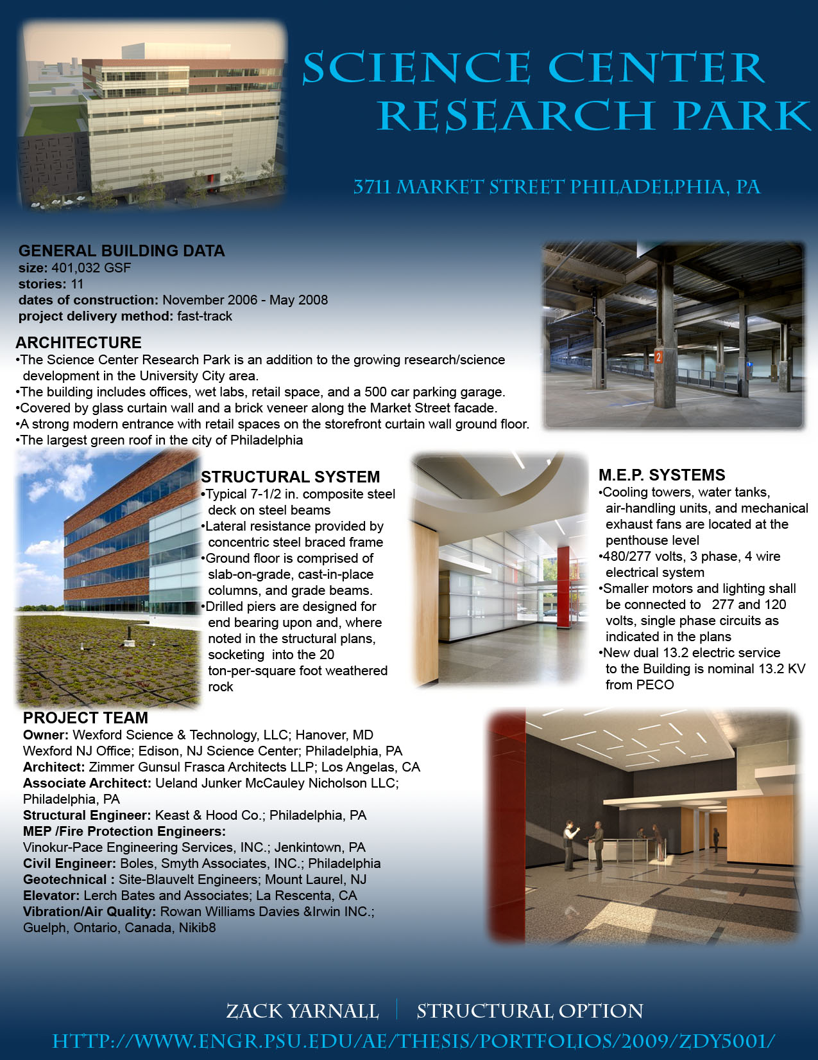
Table of Contents
EXECUTIVE SUMMARY 5

EXECUTIVE SUMMARY

The Science Center Research Park is a 401,032 GSF mixed-use building and is approximately 144 feet tall. It currently has the largest green roof in the city of Philadelphia. The building includes offices, wet labs, retail space, and a 500 car parking garage. The structure is made up of steel construction, and composite deck. Lateral support is provided by steel braced frames using HSS steel shapes for cross-bracing. The ground floor is a reinforced slab on grade with grade beams, and drilled caissons that support the buildings columns.
This report focuses on the redesign of the structure’s lateral system. It was concluded that the original steel structural design was the most economical. By maintaining this type of building structure no changes had to be made to the large spans and the open floor plan. This means the architecture did not have to face any major changes. Also, included in this report are two breadth studies which are a cost and schedule study, and a blast resistant glazing study. Cost and scheduling studies were performed to compare the effects caused by the redesign of the lateral system. The blast resistance glazing was done as an educational study as of self interest.
The depth study explores the option of building the same building design in San Francisco rather than Philadelphia. Due to the location change, the seismic lateral load would be much larger and would control over the wind load. To reduce the weight of the building, light weight concrete was used in place of normal weight concrete used in the composite steel deck of the building. Vulcraft catalogs were used to design the new floor slab, and a 3D model in ETABS was used to design the preliminary lateral system. Alternate lateral systems were researched, but a dual system was chosen for design. Concentric braced frames were not used by themselves, because the lateral load was too large, and adding lateral resisting frames in different locations would have taken away from the architecture and open floor plan. The dual system includes shear walls and concentric brace frames that are used to resist the large, controlling seismic load. The shear walls are 16” in thickness and are located in place of the concentric braced frames in the core of the building. Hand calculations were performed to confirm and complete the design of the new lateral system. Through cost analysis, it was found that the new lateral system costs over $100,000 dollars less than the original design. But the construction schedule was found to be pro-longed, because construction of concrete walls is a longer process than steel erection.
At the end of this report is an appendix that contains all the calculations for the loads stated above.

